**West Coast Collaborative**

**Investigation 1 2016**

**Circles in the Complex Plane - Validation**

**Calculator but no notes allowed in the validation.**

**Name: _______________________________**

*Answer all questions in the spaces provided and provide full working to justify your answers.*

Time allowed : 50 minutes Maximum marks = 29

1. (2 marks)

From your work on the recent take home paper what two features are most relevant to the locus of points which are equidistant from two given points in a complex plane?

*The locus of these points is a straight line √*

*which is the perpendicular bisector of the line segment joining the two points. √*

1. (1 mark)

Write the equation for a locus of points equidistant from two given points which is appropriate for a complex plane where the two points are A (a,b) and B (c,d).

 *√*

1. (6 marks)

Given that A is the point (3, 6), and B is the point (-4,3), on the grid paper provided, use a compass and pencil to sketch the locus. Mark 4 well spaced points on the locus and verify that distance from A = twice the distance from B. What is the locus suggested by your diagram?

*The locus of these points is circle ( or circle is drawn on the graph) √*

*Points A and B are correctly represented and graph to consistent scale√*

*One mark each point, verified distance from A = twice distance from B either mathematically or by measurement √√√√*

1. (7marks)Using vector techniques and relevant diagrams, prove that the radius of the circle which is the locus of points that satisfy the equation , is given by the expression 

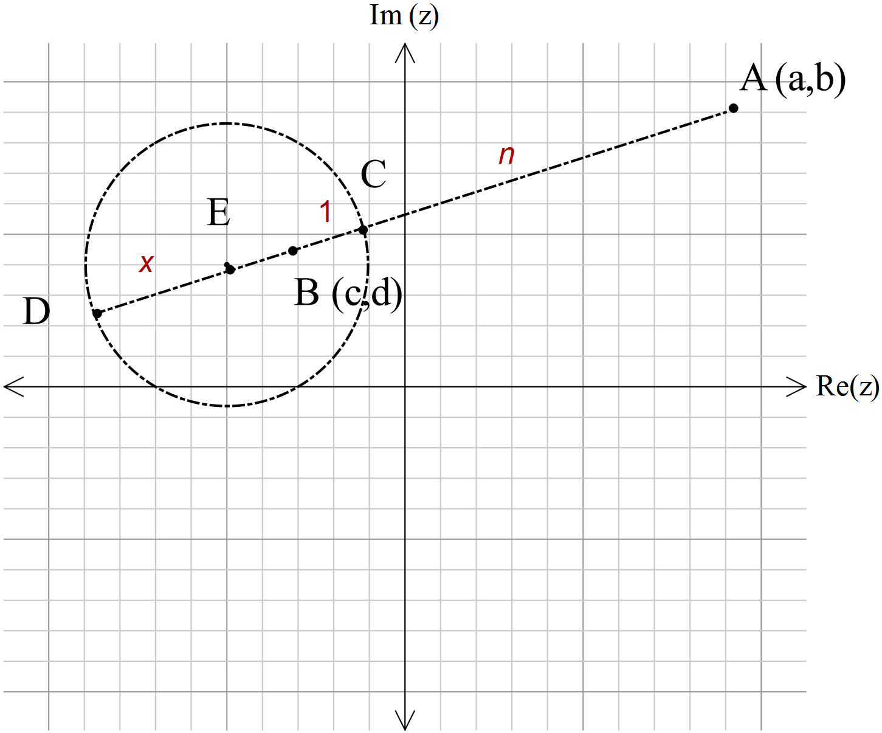

*In the diagram shown E is the centre of the circle where C and D lie on the circumference.*

*The point C is n times further from A than from B.*

*Likewise D*  *is n times further from A than from B.*

If we make 

Then √

 √





√

*So* 



√



√

*Radius* √ and  √

**√

**

**

**

5 (1, 4, 2, 3, 3 =13 marks)

For the situation described in question 3 above,

1. Determine the **exact** distance between A and B.

 = √

1. Use the equation for r above, and the value of AB to complete the table below, rounding to 3 significant figures. (-1 mark max on this requirement)

|  |  |  |
| --- | --- | --- |
|  | r( radius) | (Actual) |
| 0.01 | -0.0762 | -0.07616534759 |
| 0.1 | -0.769 | -0.7692700107 |
| 0.25 | -2.03 | -2.030872828 |
| 0.5 | -5.08 | -5.077182071 |
| 0.75 | -13.1 | -13.05561104 |
| 0.95 | -74.2 | -74.20496872 |
| 0.999 | -3810 | -3805.981657 |
| 0.9999 | -38100 | -38076.96149 |

√√√√ (half mark each)

1. What happens to the locus of the circle as  moves arbitrarily close to unity? In the limit, what is the shape of that locus?

*The locus moves to the mid-point of AB* √ *and is a straight line in the limiting case.* √

1. What happens to the locus of the circle as  increases? In the limit (as n approaches infinity) where would that locus cross the line AB, and what form would it take*? The locus moves towards point B,* √ *remains a circle but with a radius decreasing to zero.* √ *In the limit the locus is point B*. √
2. What happens to the locus of the circle as  moves gradually close to zero? In the limit (as n approaches zero) where would that locus cross the line AB, and what form would it take?

*The locus moves towards A,* √ *remains a circle but with a radius decreasing to zero*√ In the limit the locus is point A. √